PARENT HANDBOOK

New Covenant Preschool

2017 - 2018

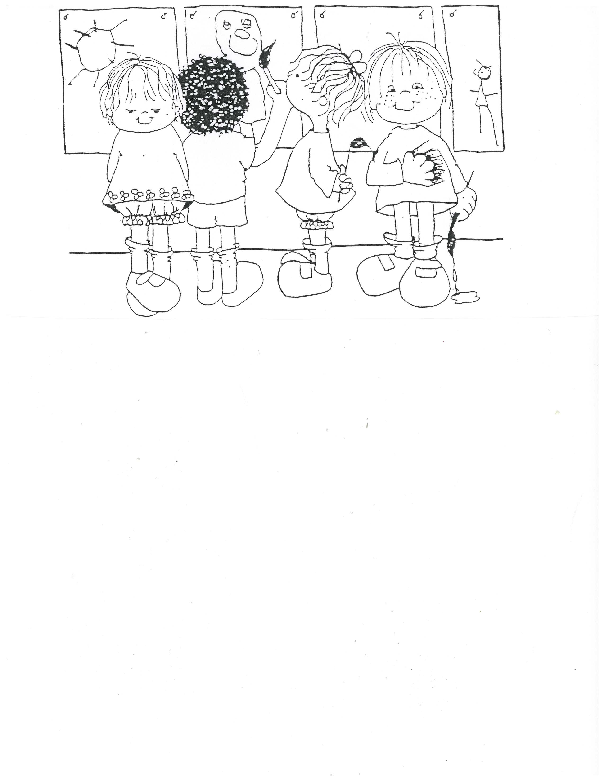

800 Tuskawilla Road,

Winter Springs, Fl 32708

407-699-0040

Susan@new-covenant-church.com
MISSION

The mission of New Covenant Preschool is to provide our students and their families with a loving and nurturing Christian environment in which the children will grow and develop academically and physically, as well as spiritually, in their love and understanding of God.

PHILOSOPHY

Early childhood is a crucial period in the development of a child. In these early years, the child is most eager and receptive of learning experiences. We believe that school for young children is very important and that their way of learning is different from that of older children.

Our early childhood program is a mixture of structured activities and information learning experiences. Our teachers provide a happy and challenging environment with carefully planned learning activities which stimulate the growth and development of each child. The physical, emotional, mental, social and spiritual development of the child is considered vital.

CORE VALUES

In pursuit of our mission, New Covenant Preschool is committed to the following core values:

We believe God has a unique plan for every child’s life. We are humbled He has called us to be a part of His plan and earnestly strive to honor Him in all that we say and do. Jeremiah 29:11 “For I know the plans I have for you," declares the LORD, "plans to prosper you and not to harm you, plans to give you hope and a future.”

We believe in the uniqueness of each child’s God given ability and assert that all children can thrive in an appropriate environment. Proverbs 22:6 “Train a child in the way he should go, and when he is old he will not turn from it.”

We seek to create a love of learning through a child-centered, play-based environment that values and encourages curiosity, exploration and discovery. 1 Corinthians 13:11 “When I was a child, I talked like a child; I thought like a child, I reasoned like a child. When I became a man, I put childish ways behind me”

We desire to develop a Christian culture in our school where we understand, implement and hold one another accountable to Biblical principles of conduct and attitude. Philippians 2:5 “Your attitude should be the same as that of Christ Jesus.”

We believe in fostering authentic partnerships with families that will support their role as their child’s primary teacher. Deuteronomy 6:6-7 “These commandments that I give you today are to be upon your hearts. Impress them on your children. Talk about them when you sit at home and when you walk along the road, when you lie down and when you get up.”

We believe in establishing and maintaining relationships with families that result in open communication, collaboration and a sense of belonging. 1 Thessalonians 5:11 “Therefore encourage one another and build each other up.”

ANTI-VIOLENCE POLICY

In an effort to cut down on violent or aggressive play, toys, clothing and paraphernalia that instigate aggressive play may not be sent or worn to school. These items include, but are not limited to, toy weapons (guns, swords, light sabers, pirate swords, and knives) and war figures. Should a child bring any of these items to school, the parent will immediately be called to come and take the item home. These items will not be able to stay in your child’s tote bag or cubby. Please use your best judgment when dressing children and purchasing lunch boxes also. Superheroes may cause aggressive play. We appreciate your cooperation.

INCLUSION POLICY

New Covenant Preschool staff believes that preschool should be a place where all children can have the opportunity to be successful. It is a time for children to learn new and exciting things, to make friendships, to try out their wings, and to learn to be a part of a group, while retaining their unique individuality. In believing that every child has his or her own “special needs”, it has always been the policy of New Covenant Preschool to be a school that includes all children.
Decisions that have a major impact on children, such as enrollment or placement, are never made on the basis of a single developmental assessment or screening device but are based on multiple sources of relevant information, particularly, observations by teachers and parents. To identify children who have special learning or developmental needs and to plan appropriate curriculum and teaching for them, developmental assessments and observations are used.

DIVERSITY STATEMENT

The Center does not discriminate in the enrollment of children or selection of staff or volunteers upon the basis of race, cultural values or beliefs, age, gender, national origin, mental or physical disability or status as a veteran.

DISCIPLINE

It is the school’s policy to use redirection, modeling positive reinforcement whenever possible in eliciting proper behavior. One of the most important things that a child learns in preschool is how to get their needs met in socially acceptable ways. It is our belief that positive discipline includes being clear with children that their actions, such as pulling hair, pushing, and hitting, will hurt people and cannot be allowed. Teachers will provide natural consequences which will allow the child to understand that actions result in consequences. For example, if a child tears a book, the natural consequence is that the child will assist the teacher in repairing the book or bring in one of their own as a substitute. Teachers will use firmness, coupled with removing the child temporarily and redirecting his/her attention to something else. For preschoolers, a big part of learning social skills involves learning about feelings. This can be a good opportunity to teach that there is a difference between a feeling and an action, and to help the child learn to identify and cope with his/her feelings.

Because a child’s self-concept is at its most formative period during the preschool years, and because a child is so easily influenced by the words of those adults who are important to him/her, it is important that members of the staff never tell a child that he/she is bad, mean or use other such descriptive words. A child looks to adults to help him/her control their behavior. It is important that these adults let the child know that it is his/her behavior that is not acceptable not the child who is unacceptable. The staff might say,” I can’t let you hit the other children in the room. That is hurtful and not safe”. By utilizing these policies, it is hoped that the staff will help children respect other human beings as well as themselves. A child needs patient, loving adults to model the appropriate negotiation and problem solving skills for them to become successful and non-violent members of a group.

At no time is corporal punishment, such as spanking, hitting, yelling or humiliation allowed to be used in the Center nor should they ever be threatened with punishment. Should a teacher find it necessary to isolate a child who is so disruptive that normal classroom operation is impossible, they will be well supervised while isolated from the rest of the class. The child will be allowed to return when he/she is able to show respect for the rights of other members of the classroom. A child is never to be left unattended or in a frightening or uncomfortable environment. Any child who is so disruptive that the teacher cannot deal with them by using positive means of discipline, will be referred to the Director for further evaluation and possible consultation with parents and or other professionals. The school does reserve the right to require parents to pick up any child who is especially unruly.

Occasionally, it is determined that a child needs to be withdrawn from New Covenant Preschool. This is only recommended after very careful observation of the child and ongoing meetings with the parents. One or more of the following conditions must be present to suggest exclusion: the child’s behavior is harmful to himself or the other children in the program, we are unable to meet the individual needs of the child or the child’s behavior is disruptive to the point of preventing the other children from learning. This is done only after all reasonable options have been attempted. This decision is made with input from the classroom teachers, the parents and the school administration.

WHEN YOUNG CHILDREN BITE

Our program recognizes that biting is, unfortunately, not unexpected when toddlers are in group care. We are always upset when a child is bitten in our program and recognize how upsetting it is for parents. While we feel that biting is never the right thing for toddlers to do, we know that they bite for a variety of reasons. Most of these reasons are not related to behavior problems. Our program does not focus on punishment for biting, but on effective techniques that address the specific reason for the biting. When biting occurs, we have three main responses:
- Care for and help the child who was bitten.
- Help the child who bit learn other behavior.
- Work with the child who bit and examine our program to stop the biting.

Our teachers express strong disapproval of biting. They work to keep children safe and to help the child who bit learn different, more appropriate behavior. When there are episodes of ongoing biting, we develop a plan for specific strategies, techniques and timelines to address it. We do not and will not use any response that harms a child or is known to be ineffective. We give immediate attention and, if necessary, first aid to the child who is bitten. We offer to put ice on the bite if the child is willing. We clean the wound with soap and water.

When a child bites, their parents are informed personally and privately the same day. When a child is bitten, their parents are informed personally that day and given a copy of our accident form. When we experience ongoing biting in a toddler room, we develop a written plan with specific strategies, techniques and timelines to work on the problem. This written plan is shared with the parent of the biter. Biting is always documented on our standard bite report. It is completed and signed by a teacher and an administrator. One copy is given to both the team supervisor and director of the program. We keep the name of the child who bit confidential. This is to avoid labeling and to give our teachers time to work with the child who is biting.

CURRICULUM
We have chosen The Creative Curriculum for our preschool. “The Creative Curriculum® is widely regarded as a forward-thinking, comprehensive, rigorously researched curriculum approach that honors creativity and respects the role that teachers play in making learning exciting and relevant for every child.” Creative Curriculum’s guidelines are consistent with our mission to provide children with an educational foundation that will enable them to reach their full God-given potential through experiences and activities that support the development of the whole child. For more information visit: www.teachingstrategies.com/page/ccs_overview.cfm

ADMISSION REQUIREMENTS

New Covenant Preschool will enroll children who have reached the age of 18 months, 2, 3, or 4 years old by September 1st into the older ones, 2, 3, and 4 year old class, respectively. Beginning with the three year old classes, all children must be potty-trained and working towards self-sufficiency in their toileting skills. Children will be enrolled without regard to race, color, sex, religion, or national origin. Returning students, siblings and children of New Covenant Church members and their siblings will be given registration priority. Open registration will be held for members of the community when current member registration has been completed. Once open registration begins, all children are registered and/or placed on a waiting list on a first come - first served basis.

PRESCHOOL FEES

Registration - $75 per child (18mo. – 3’s, Due at registration, Non-refundable & Non-transferable)
Supply Fee – Due at registration, Non-refundable, Non-transferable
1-day/week - $45
2-days/week - $100
3-days/week - $140
4-days/week - $160
5-days/week - $200

Tuition - (Tuition is divided into 10 equal payments. There is no reduction in the amount of tuition for those months in which your child is absent)
1-day/week $950/year or $95/month
2-days/week $1900/year or $190/month
3-days/week $2750/year or $275/month
4-days/week $3600/year or $360/month
5-days/week $4150/year or $415/month

TUITION PAYMENTS
It is our desire to provide a quality preschool or experience for all children enrolled at New Covenant. We charge a reasonable amount for tuition and we collect it on time. Tuition is due on the 1st of each month from Aug. through May. When tuition is not received by the 7th of the month, a late fee of $10 will be assessed. In cases where more than 1 child from a family is enrolled in our program, a single discount of 10% will be applied to the monthly fee of the child whose tuition is the least.
Payments must be placed in an envelope and attached to your child’s tote bag or mailed to school (New Covenant Preschool, 800 Tuskawilla Road, Winter Springs, 32708). Please DO NOT hand payment personally to teacher.
There is a $25.00 service fee assessed to all returned checks. Once a check has been returned, further payments must be paid either by money order or cash.
If, for any reason, you withdraw your child for the remainder of the school year, you are asked to notify the Director at least 30 days in advance. Tuition will be due for the following month if less than 30 days’ notice is given. Registration and Supply fees are non-refundable.

VPK
In 2005, Florida instituted the VPK (Voluntary Pre-k Program) stating that the Pre-kindergarten year is very important and all Florida’s children should have access to attend. The state came up with a program consisting of 540 educational hours to be designated as VPK hours with specific educational standards, credentialing criteria for teachers and strict attendance guidelines for parents.

All of these items had previously been incorporated into New Covenant’s Pre-k program, and we saw the need for and decided to participate in the Florida VPK program. However, our regular Pre-k program ran 5 days a week for a total of 668 educational hours. In order to do this, we had to carve out specific days of the week and hours per day to total 540 hours and call them VPK hours. Therefore, the VPK-only program at New Covenant Preschool runs Monday through Thursday only, from 9am-1pm, at no cost. Families that want to take full advantage of our regular New Covenant Pre-k (VPK-Plus) from Monday through Friday, for a total 668 educational hours, are asked to pay a monthly tuition of $105 to cover the cost of the additional educational hours.

Parents choosing to enroll their children in the VPK program are responsible for complying with the attendance policy, verifying student attendance each month, and presenting their child for the state kindergarten screening, regardless of whether the child attends kindergarten in a public or non-public school. Students are expected to attend at least 80% of the program. The state will not pay for absences that exceed 20% of the program length. VPK providers have the option of dismissing children for excessive absences. Absences must be documented with a written note to the child’s teacher and will remain in their file.

INFORMATION TO BE ON FILE FOR ALL CHILDREN

In order to ensure the health and safety of your child, the following information is required to be on file for each child enrolled at New Covenant. These are the requirements by DCF (Dept. of Children and families)
- Current Medical examination certificate
- Current Immunizations Record
- Emergency Medical Release Form
- School Registration Form
- Signed receipt of Parent Handbook Acknowledgement
- Food Allergy Information & Outside Food Release

All information listed above must be complete and in each child’s file within 30 days of enrollment. Parents are required to keep their child’s information up to date on file. Children’s files that are missing, or have outdated information, may not attend class until files are updated and complete.

KIDS KLUB: (3 year old and Pre-k classes only)

Within the first few weeks of school, we will start our KIDS KLUB program. You will be notified of the start date. On Thursdays, your child will be able to stay until 2 pm. The cost for your child to stay for this optional program is $5.00 a day. If your child plans to stay for KIDS KLUB, just send in $5 in an envelope attached and labeled with child’s name and KIDS KLUB to their tote bag in the morning. Coupons are available for easier KIDS KLUB payment. They are 4 coupons for $20. Send in a check or cash in envelope and write KIDS KLUB coupons enclosed.

LUNCH AND SNACK

Mid-Morning Snack - Each family will be responsible for sending a small snack daily for your child. Please provide a small nutritious item. Do not place items in child’s lunch box. Place items in a small zip lock bag with your child’s name on it and clip it to the front of your child’s tote bag. We will provide drinks. The children will be well hydrated.

Lunch - Please pack your child a small lunch every day. Ideally, it should be small finger type food, ½ a sandwich, a few goldfish, a piece of cheese, apple cut up and a small juice box. Please place an ice pack (cold pack) in their lunch box. We DO NOT have refrigerator capacity, nor DO we have the ability to heat foods. PLEASE LABEL the outside of all lunch boxes with your child’s name.

Birthdays
Your child’s birthday could be celebrated in the classroom during snack time. Feel free to talk to your teacher about snacks that would be appropriate should you want to send something special. The foods listed below make great healthy substitutions for cookies or cupcakes. If you want to send birthday invitations or thank you notes to be passed out at school, they must include everyone in the class. That way no one’s feelings will get hurt. We will make addresses available if you want to include only part of the class.

Celebrations

Healthy Habits for Life

With all types of celebrations occurring throughout the school year it is important that we remain mindful of our healthy habits initiative and school wide curriculum. Children are learning every day about healthy food choices and lifestyle. With this in mind, you will find alternatives to cookies, cakes and cupcakes when planning a classroom celebration for a birthday or holiday.

Fruit Kabobs
Fruit Parfaits
Mini bagels and cream cheese
Apple slices with honey, yogurt or soy butter
100% Fruit Popsicles
Frozen Yogurt sundaes
Veggies and dip
Fruit Salad with whipped cream
Rice cake faces with cream cheese and raisins
Banana boats

GENERAL POLICIES AND PROCEDURES

SCHOOL HOURS: 9:00AM – 1:00PM
Classes begin promptly at 9:00 am. It is very important to your child that they arrive on time. The teachers need this time to observe and assist each child in beginning their day. Doors will open at 9:00 am. You are welcome to play with your child on the playground should you arrive before 9:00 am.

Children will be ready to leave at 1:00 pm when the doors open. Please be prompt in picking up your children. When parents are late, the children become anxious. We understand that emergencies occur. Should that happen, call the office before 1:00PM. At 1:10 PM, children will be taken to the Preschool Office and a $15.00 late fee will be assessed. Keep our number, (407) 699-0040, for reference. You may want to set us on speed dial.

Please let the office know when your child is absent. That includes illnesses and vacations. We worry when a child is absent and a call can help us know how to pray.

TRANSPORTATION PROCEDURES, Doors open at 8:55 for drop off & 12:55 for pick-up:
YOUR CHILD’S SAFTEY IS OF OUR UTMOST CONCERN. For this reason it is extremely important that we have your full cooperation in following the transportation procedures below.

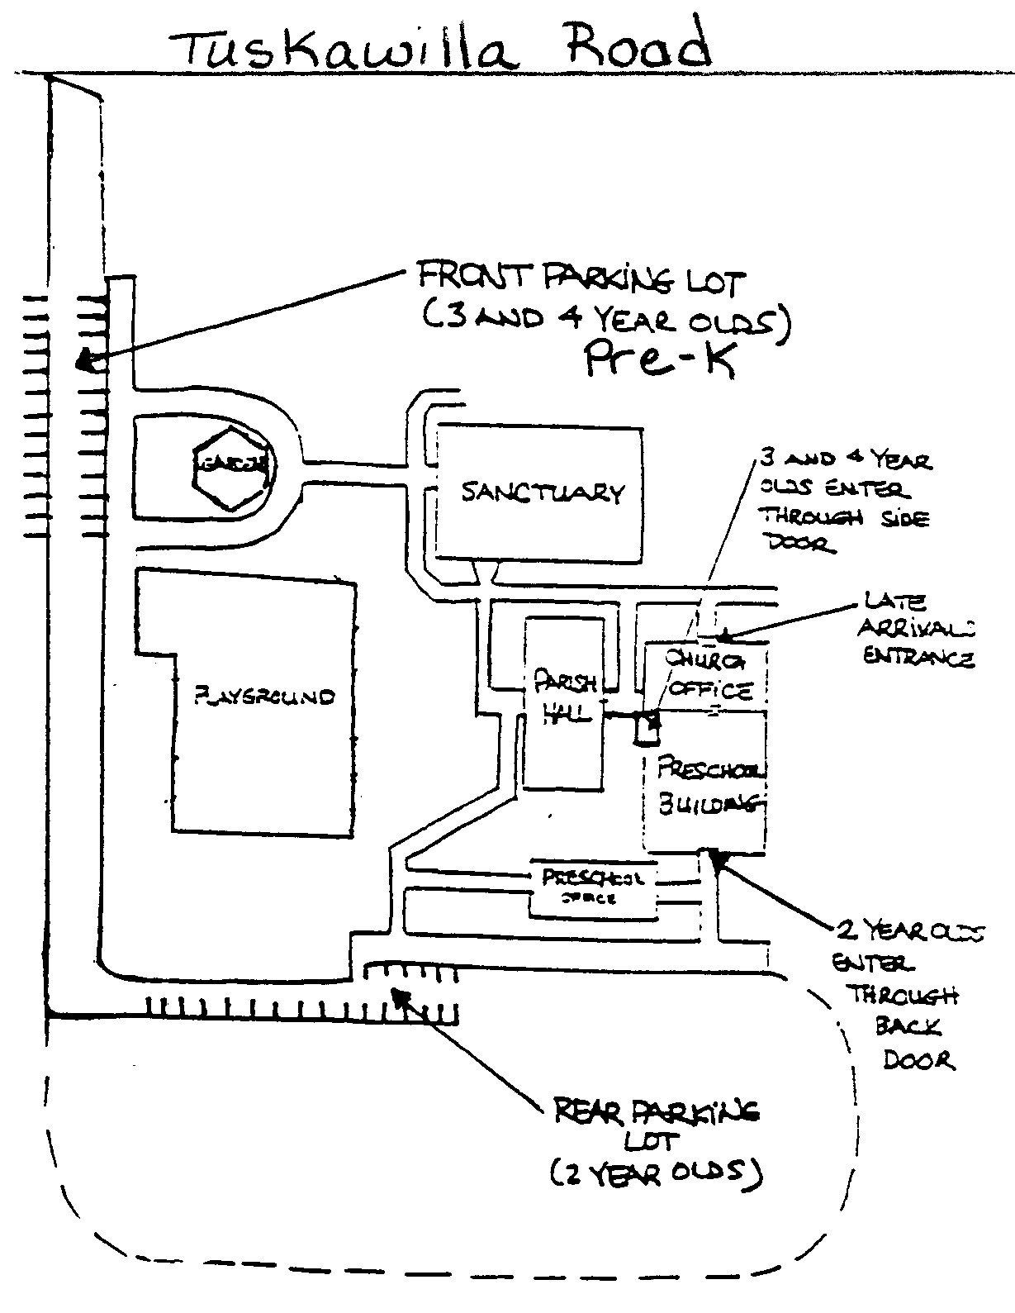 DROP OFF PROCEDURES:
Children in the Two-Year-Old classes should
enter the building from the back parking lot
through the back porch door. Parents will sign
their child in for the day. Children will then be
lifted over the half door of the Nursery to the
teacher when you are ready. At the end of the
day parents will also sign out their child.

Parents of children in the Three Year Old and
VPK/Pre-k classes should park in the front lot by the
playground. Walk your child to the side door of
the school (doorway opposite the Parish Hall,
where the steps are). Someone will be there to
greet the children between 8:55 and 9:10 to make
sure they get to their classroom safely.

Anyone arriving after 9:10: To prevent disruption
of classes, which have already begun, please enter
through the Church Office door. Someone will be
available to take your child to class.

PICK-UP PROCEDURES:
Doors will open at 12:55 pm. Teachers enjoy the
chance to briefly talk with parents at this time.
All persons picking up must sign–out, including
time, for each child.

As in the morning, Two Year Old parents park
in the rear and enter through the back porch
door.

Parents of children in the Three Year Old
and Pre-k classes park in the front lot, enter through
the side door of the school and meet your child
in their classroom.

***Please be prompt – at 1:10 pm children will be taken to the Preschool Office
and a $15.00 late fee will be assessed per child.

For your safety and the safety of others, please:
DRIVE SLOWLY AND WATCH CAREFULLY FOR CHILDREN IN THE DRIVEWAY

CALENDAR:
We follow the Seminole County School calendar as closely as possible. We also follow their decisions for school closings due to inclement weather or hazardous conditions.

TOTE BAGS:
Each child will receive a tote bag from the school for carrying papers and schoolwork. On the bag will be a large binder clip. When we have important information for you, it will be clipped to the front of your child’s bag. Likewise, when you have notes for us, please attach them to the front of the bag. Please put ALL MONIES (tuition, kids klub, field trips, etc.) in a labeled envelope and clip it to the bag for your child’s teacher. Please send your child’s bag to school each day.

CLOTHING:
Please send your child to school in play clothes. Though we wear smocks, accidents can happen! In order to encourage independence and lessen the chance of accidents, send your child to school in clothes that are easy to undo at bathroom time. Appropriate clothing is:
- Easy to manipulate at bathroom time – i.e. elastic waists, snaps rather than buttons, snaps all the way to the cuffs on those who wear diapers
- Appropriate for the weather – a jacket or sweater when it is cool
- Sneakers, no sandals or Croks– easier climbing outside and less insect bites
Please send a complete change of clothing for your child to keep at school in case of accidents. We will send home soiled clothing (including socks) in a plastic bag. Return another change of clothes the next day when your child comes to school. Each piece of clothing should be labeled.

FIELD TRIPS: (Pre-k Only)

We will, on occasion, be taking field trips away from school. We must have written permission for your child to participate in these school-supervised trips. Under NO circumstances are we
allowed to take a child off school grounds without your written authorization. You will receive a note to sign prior to the day of the field trip with the details for that particular trip. Please return that form promptly. If you plan to drive on any field trip, we will need to have your automobile insurance information on file. We do not allow siblings to go along. (Make friends with another mom with younger children and plan to take turns watching the little ones and driving for field trips.)

ILLNESSES:

Please call to let us know if your child will be absent from school. Please notify the school at once if a communicable disease (Chicken Pox, Impetigo, Lice) is contracted
For the safety and concern of your child and the others in your class, please keep your child home if he or she:

.has a fever or has had one in the last 24 hours
.has diarrhea that occurs 3 or more times in the last 24 hours
.has heavy nasal discharge
.has a constant cough
.has vomited in the last 24 hours or has a fever with vomiting
.has an undiagnosed rash on his/her face or body
.has been diagnosed with strep throat and has not had antibiotics for at least 24 hours
.seems unusually tired or cranky
.has any unusual symptoms of a possible communicable disease

We will notify you to come get your child if any of these symptoms occur during school hours.

All children MUST be symptom free for 24 hours before returning to school.
Children must have both a current physical and State Health form showing proper immunizations on file to attend school.

Parents, we love for you to visit and help in the classrooms, after your child has adjusted to school. Please discuss visits and volunteering with your teacher.

We welcome your suggestions and ask that any grievances be brought to the attention of the Director and not to another parent.
This is your school and we want to make it the best!

PARENTAL AGREEMENT

LATE PICK-UP FEE:
Please be prompt in picking up your children. We understand that emergencies occur on occasion, but should that become excessive, a late fee of $15.00 is assessed after 1:10PM.

I have read and agree to the policies outlined above and in the Parent Handbook.

XXXXXXXXXX XXXXXXXXXXX
Date Parent Signature

THIS COPY IS FOR YOUR RECORDS

