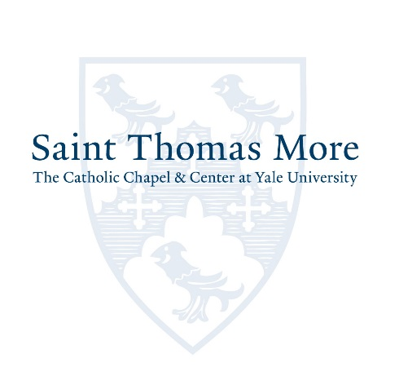

Summer Ambassadors Program

The STM Ambassadors program offers you an intensive, summertime initiative focused on helping the underserved population here in New Haven or wherever you are spending the summer.

You will need to select a non-profit agency of your choice, work with them on a creative new idea that addresses a need and then submit a proposal for funding to STM. If selected, you and your agency could receive up to $5,000 ($2,500 for the agency and $2,500 for your stipend) for your work. Your project is meant to bring together the needs of the agency with your own personal passion.

In the past, students set up a library in El Salvador to promote literacy as well as developed a living history recording project. Other possibilities could be working to provide additional services at a local soup kitchen, working with a summer educational program, working with a local environmental agency to expand awareness, working at a legal aid clinic, providing cameras and journalistic education for a homeless population to tell their stories, etc.
Dates:
- April 9, 2017: Application Deadline
- August 15, 2017: Summer project completed
- September 17, 2017: Project Presentation Deadline (If you will not be in New Haven, the presentation must be in a 5 minute video format that can be shown at a dinner.)

Requirements and Stipend:
- Open to all students
- You must work at least 80 hours but not more than 160 hours over the course of the summer.
- The hours are flexible to suit your schedule as well as the agency.
- You will be paid between $1,250 and $2,500 as a stipend for your work.
- Final payment will be received upon completion of the final presentation.

You may apply in teams to work at the same site with coordinating projects.
Deadline for applications is April 9th.
Email completed application to jennifer.schaaf@yale.edu.

This program is funded through a generous donation from the Smart Family Foundation.

Application for Summer Ambassador Program

Full Legal Name (As it appears on your Passport or Driver’s License)

College or Graduate/Professional School Anticipated Graduation Year

______________________________________________________________________________________
Cell Phone

______________________________________________________________________________________
Local Address

______________________________________________________________________________________
Permanent Address

______________________________________________________________________________________
Social Security Number

Describe your involvement at Saint Thomas More.

Describe your involvement in current and past volunteer or social justice opportunities.

Describe the agency you plan to partner with this summer. Include the name and address of the agency, as well as the name and contact information for a person at the agency who will operate as your site supervisor.

Describe your vision of what you hope to accomplish through the partnership with the agency. What social justice or service need is being provided for? How is what you are doing different from what the agency is already accomplishing? What skills or information do you have that will be beneficial to the agency? What do you hope to learn as part of the experience? How does this connect with the Catholic faith tradition?

Provide a detailed budget, which can be up to $2,500, for the project. This should include any supplies or publicity the agency will need to make the project successful. Please note, as this program is to aid students in providing service where they already plan to be over the summer, travel to and from the location will not be provided as part of the project budget. You may cover travel expenses with your personal stipend. If you have applied for or received any other funding for this project, please include a copy of those budgets and the timeline of when you will be notified of the award.

ITEM | ANTICIPATED AMOUNT | WHY IT IS NEEDED FOR THE PROJECT

