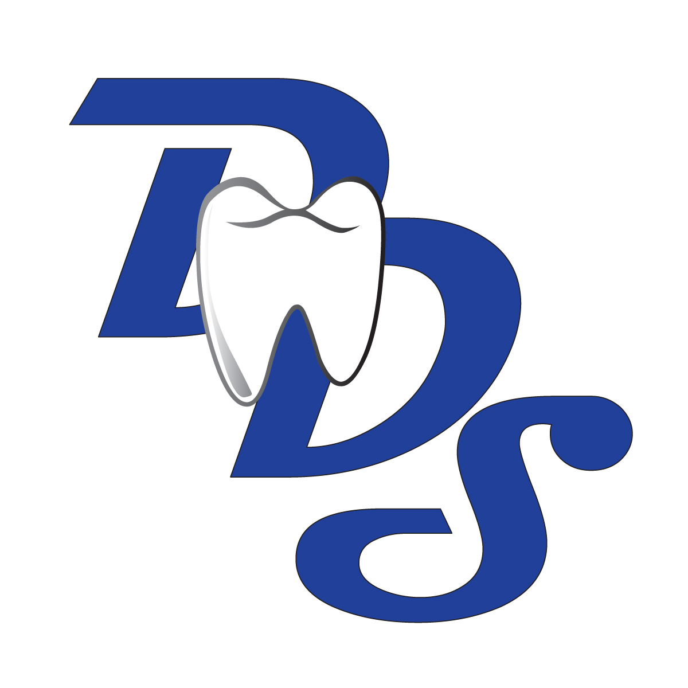
DENTAL DYNAMIC STAFFING, LLC
TIME SHEET
FULL SERVICE CLIENT
Fax: (440)212-7094

Must be received no later than 8:00 am the following Monday.
Client Name: | Employee Name:
Location: | Employee SS#: XXX-XX-
Position: ⁭ DA EFDA ⁭ RDH ⁭FO ⁭ other | Week Ending Date:

Date | Date: | Clock In | Lunch Starts | Lunch Ends | Total Lunch: | Clock Out | Total Hours
Sunday
Monday
Tuesday
Wednesday
Thursday
Friday
Saturday
 |  |  |  |  | Full Service | TOTAL HOURS

I certify the hours shown above were worked by me and were approved by an authorized representative of the Dental Facility or Office. It is my responsibility to contact Dental Dynamic Staffing upon completion of each assignment to request a new assignment or it will be deemed that I have voluntarily quit my employment which may impact my eligibility for unemployment benefits. Timesheets are due at the completion of the day /weekly shift. One time sheet per office. If a mistake was made on my timesheet that was already faxed, I will contact Dental Dynamic immediately. If Dental Dynamic does not receive my signed time sheet, no check will be produced. I further certify that I have previously read and understand and agree with the terms of the Candidate Agreement which I have previously executed.

Employee Signature: ______________________________________________

It is hereby agreed that the hours stated are correct and the work was performed satisfactory. It is understood that overtime at time in a half will be billed over forty hours per week if initialed by client/supervisor next to overtime hours. Time and one half is charged for the six national holidays. 1 ½% is charged on all accounts past due over 30 days. All court costs and legal fees will be the obligation of the client for the collection of a delinquent account.

Supervisor Signature: ______________________________________________
**Must be signed to receive a paycheck***

Evaluation Box: Please take a moment to write any additional comments that might be helpful to service you better.

THANK YOU FOR YOUR BUSINESS!

