SHOW ME THE DATA
- An extensive collection of over 2000 research studies that support Action Based Learning collected over 20 years
- Medical University of South Carolina study
- Physical Activity, School Performance May Be Linked
- Do Students Think Better on Their Feet
- How Can We Increase Kids Attention Spans
- Chamberlayne Elementary Video
- FIT Kids Time in Target Zone and Cognitive Performance
Dr. Darla Castelli and Dr. Charles Hillman et al
- Exercise boosts brain function (Dr. John Medina)
- Exercise improves cognition (Dr. Robert Sylwester)
- Exercise strengthens memory (Dr. John Ratey)
- Exercise prepares the brain to learn (Dr. John Ratey)
- Exercise regulates behavior (Dr. John Ratey)
- Exercise weakens the ill effects of poverty (Dr. Eric Jensen)
- Exercise can positively change the brain (Dr. John Ratey)
- Exercise helps boost BDNF to alleviate symptoms of ADHD (Dr. Michael Hopkins)
- Aerobic Exercise increases learning processes (Dr. Charles Hillman) 2013
- Physical Fitness Improves Language Skills (Dr. Charles Hillman) 2014
- Obesity Impacts Academic Success (Dr. Charles Hillman) 2014
- Family Focus: Students stay active while learning at one school in Charlotte
- Program in Springdale adds exercise to academic
- Action Based Learning Lab Opens at Marshall School
- Lone Grove ABL LAB in the news
- SUPER School ABL in Indianapolis
- Jefferson Elem ABL LAb in the News
- Carlos ABL Kinesthetic classroom in the news
- Action Based Learning Unit Grundy Center Elementary
- St Gregory in Tyler Found ABL to help behavior and learning

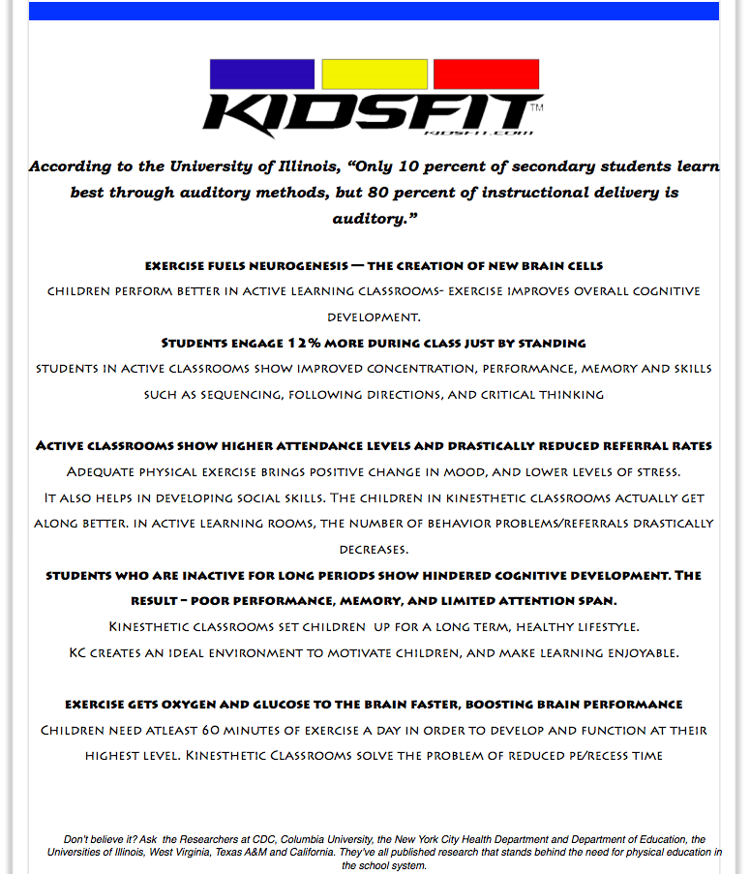
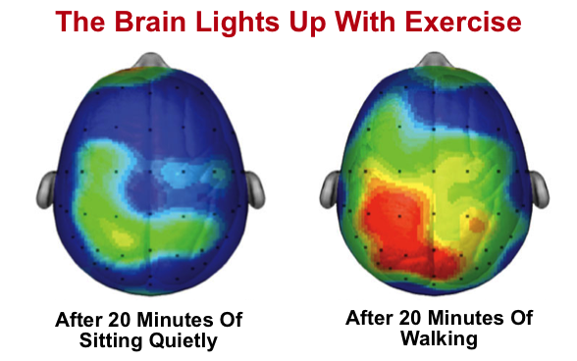
The picture above is independent research by Dr. Charles Hillman (University of Illinois Urbana). See how the brain is 'on fire' and ready to learn. And, this is just the side effects from walking. Higher intensity exercise will produce a sharper brain, which is even more ready to learn. For More Information Click Here.
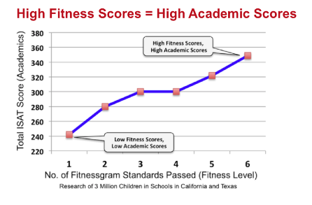
The Chart to the left reflects the correlation between increased physical activity and increased academic scores. This research was accessed from PhitAmerica and is based off of 3 million children in schools in California & Texas.
The above information was accessed via PhitAmerica. For more information please click here.

For More Research Studies Proving why "Physical Activity Results In Improved Academic Performance" See Below or Click Here.
- University of Illinois – “Physically Fit Kids Have Beefier Brains”
- University of Illinois Urbana – “How Exercise Can Boost Young Brains”
- Dartmouth – “12 minutes of exercise improves attention and reading comprehension”
- Purdue University – “Kids working out get better grades”
- Medical University of South Carolina – “P.E. actually helps academic scores”
- University of Hindenburg – “More physical activity improved school performance”
- Dundee University – “Moderate to vigorous exercise boosts academic performance”
- Strathclyde University – “Regular exercise improves children’s academic results”
- University of Western Australia – “Physical activity enhances children’s learning”
- Pediatrics & Adolescence Medicine – “Let kids play – They do do better in school”
- American Academy of Pediatrics – “Quick activity breaks reset kids' brains”
- Society of Behavior Medicine – “School-based physical activity improves academics”
- Elsevier - Higher aerobic fitness is associated with improved cognitive functions"
- Journal of Applied Measurement - "Video exercise impacts learning process"
- Furman University, Legacy Charter School - "Daily PE Improves Fluid Intelligence 75%"

KEEP THE DATA COMING

Click On The Links Below For More Research:
Data on Kinesthetic Classroom Desk study in TX
Kids Who Move While Learning May Absorb More, Study Says
Texas A&M Study Proves Benefits of Standing and Movement Desks
Lack of Exercise Impairs Students - Lancaster Online Report
Overview of Kidsfit Kinesthetic Classroom News Clip
A Neat Way To Keep Fidgety Kids Focused - Montreal Families
Kinesthetic Classroom Management/Classroom Management and Control for tables
Bethel Elementary and Junaluska - Elementary Implementing Kinesthetic Classrooms
Frequently Asked Questions - What Are The Teachers Saying?
No Excuses- A Documentary
Exercise Is Proven To Increase Grades!
What is Kinesthetic Learning? Defining Kinesthetic Learners

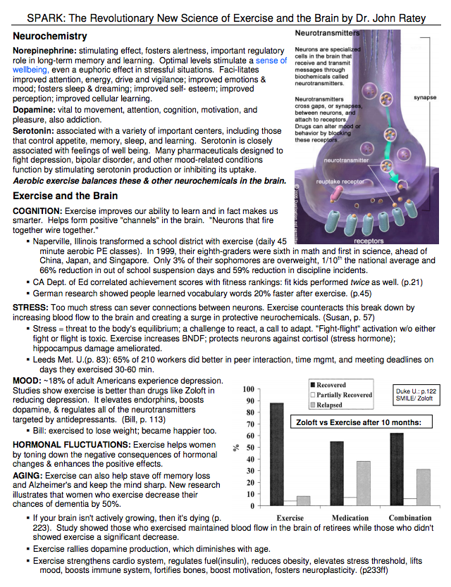
*Ratey, J., Dr. (n.d.). SPARK: The Revolutionary New Science of Exercise and the Brain. Retrieved December 29, 2016, from http://www.glgc.com/goodstuff/Ratey%20SPARK%201page.pdf
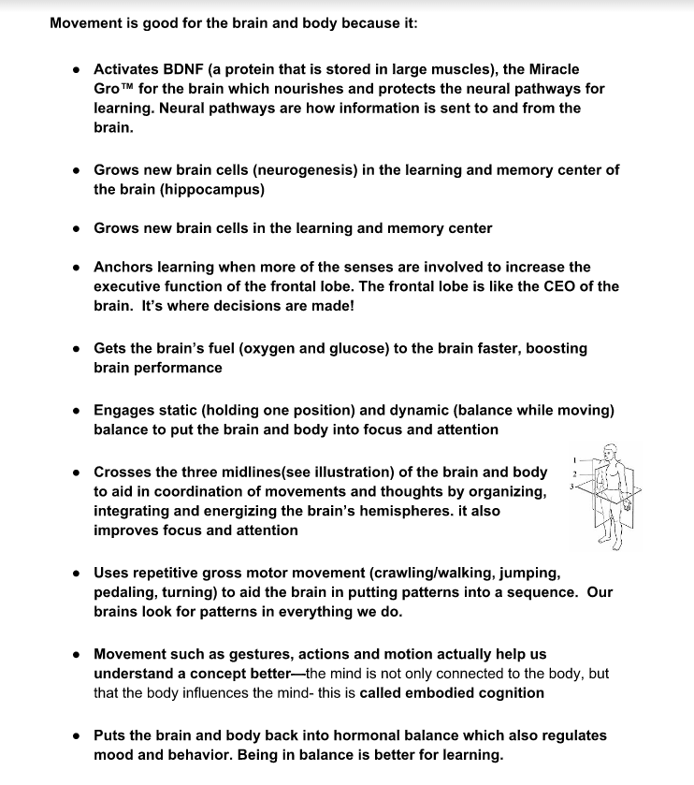

SOUTH CAROLINA: MEDICAL UNIVERSITY OF SOUTH CAROLINA (MUSC)
Double-Digit Percentage Hike in Test Scores for Students in ‘Brain Rooms’ – Charleston, SC

A major academic innovation in Charleston, SC is the creation of ‘Brain Rooms,’ which are being used in six elementary schools, one middle school, and one high school. In each school, the ‘Brain Room’ is a traditional classroom, but the children are in constant motion while learning – doing push-ups, performing sit-ups, walking on a treadmill, sitting on a balance ball, or working out on an elliptical machine.

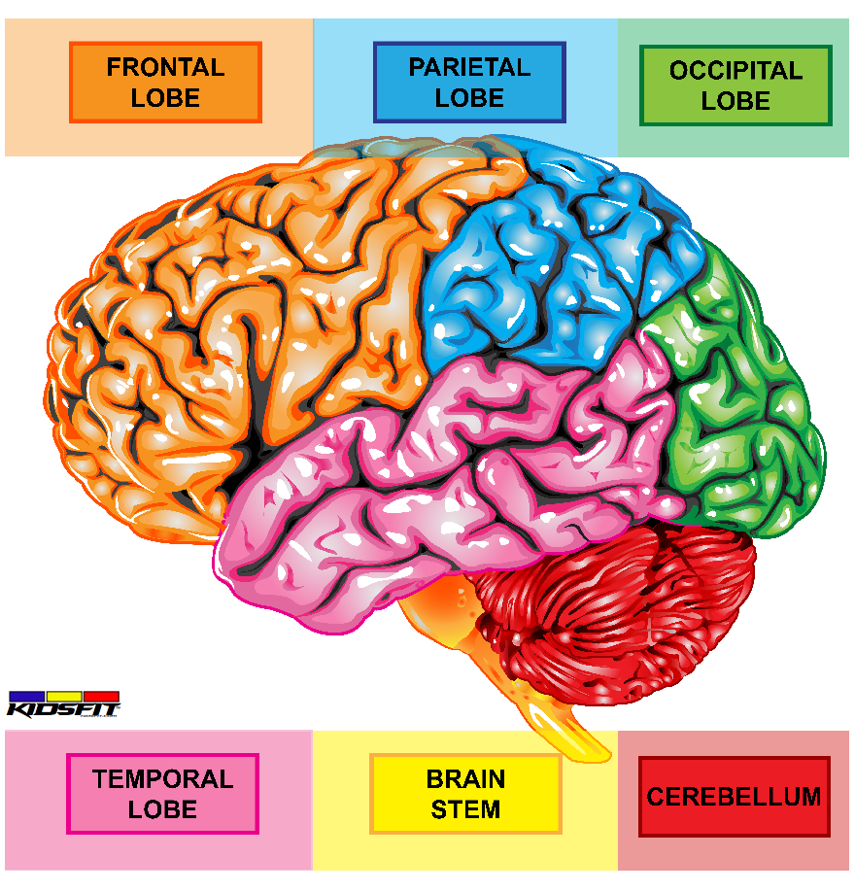
“In the ‘Brain Rooms,’ we just exchanged desks,” said Dave Spurlock, the coordinator for health, physical education, ROTC, athletics, and district wellness for the Charleston School District. “Instead of a static approach to learning, we are using a kinesthetic approach. We are proving that you must move to learn.”

At just one of the elementary schools, grades and test scores for students who were healthy and active increased by 13% to 48%, depending on the class.

“The story in Charleston, South Carolina about how physical activity is being aggressively used in the classroom setting is remarkable,” said Jim Baugh, founder of PHIT America. “Every school district in America should follow their lead. It’s time for all school district leaders in this country to ‘wake up and smell the roses’ when it comes to the importance of physical activity. Students who receive daily PE in school have a greater chance of higher test scores in class.”

“The results speak for themselves,” said Spurlock. “Physical activity truly enhances academic achievement, but it goes against the prevailing attitude in education which requires our students get more seat time.” Spurlock knows that the more students move, the more they learn.

In addition to the work being done in the ‘Brain Rooms’ in Charleston, researchers from the Medical University of South Carolina Children’s Hospital performed a study at one of Charleston’s low-scoring elementary schools in SC Children’s Hospital order to determine how implementing a daily physical education program that incorporated classroom lessons would affect student achievement. The study targeted first through sixth graders. In this experimental program, the children were given 40 minutes of P.E. each day at school (Monday through Friday). Prior to this test, the children were given 40 minutes of P.E. each week! The conclusion of the study was that more time spent outside of the classroom doing P.E. actually helped academic scores. Prior to the study, 55% of the elementary students were reaching their academic testing goals. After the study, 68.5% of the students from that elementary school were reaching their academic testing goals.

“More studies are needed, but there is growing substantial evidence that this kind of physical activity may help academic behavior, cognitive skills, and attitudes,” said Dr. Carly J. Scahill, DO, pediatric resident at the Medical University of South Carolina Children’s Hospital.

P. (2013, July 18). FOUR BREAKTHROUGH STUDIES: PHYSICAL ACTIVITY REAPS REPORT CARD RESULTS. Retrieved December 29, 2016, from http://www.phitamerica.org/News_Archive/More_Sweat___Better_Academics.htm

