Kids Need to Move!

Proposed Activity
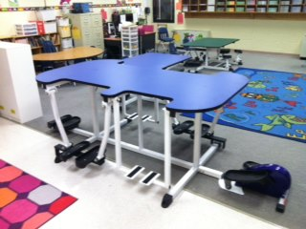
Our goal is to incorporate movement into our learning at _________ by providing our students with
different types of equipment in lieu of traditional desks. The equipment would include Kinesthetic learning tables that use bicycles, balance, ski swing, cross lateralization, and elliptical (at their seat). We would like to set up a learning environment that utilizes a kinesthetic approach. While seated or standing at the Kinesthetic learning tables the students will have the ability to use movement to facilitate cognition, maximize brain function, and anchor learning.

This project will initially impact __ students but has the capability of impacting over ____ students once implemented school wide.

Results/Outcomes
Movement Stimulates & Enhances Cognitive Development:
- Increases ability to pay attention
- Concentration span extended
- Improves short & long-term memory
- Forms Positive moods
- Supplies Brain with energy and nutrients
- Infuses the Brain with (BDNF) for growth of new cells
Regular quality movement sharpens the tools of intelligence.
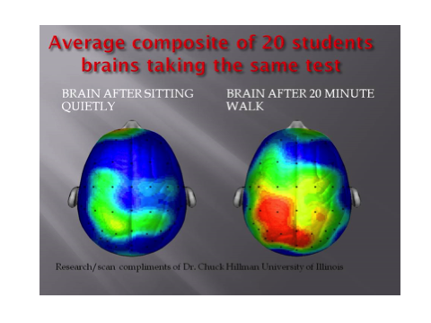
Children actually GET ALONG BETTER in Kinesthetic Classrooms, moods are improved, the children are excited about learning, the school’s academic performance ratings increase. This results in less time and money spent on student’s who are distruptive in the classroom or those students struggling to keep up academically.
Intensity and Duration
All students will be exposed to Kinesthetic learning __ days a week, for ___ minutes per day.

How do we make this happen?
This is our opportunity to take the latest Neuroscience and apply it to Education! Exercise is the ONE thing that we KNOW optimizes brain function. This is an answer to closing the achievement gap and greater achievement overall for our students.

www.kidsfit.com
RESOURCES:
Hannaford, 2008: Smart Moves Why Learning Is Not All In Your Head
Medina, 2008: Brain Rules
Jensen, 2009: Teaching with the Brain in Mind
Ratey, 2008: SPARK

