Trial Desk Pilot Program
Opens February 2018

For a limited time in the NY/NJ/CT Tri-State area, Action Based Learning is offering schools an opportunity to take a test drive on our Kidsfit Kinesthetic Pedal Desks What’s the catch? There is none! Schools who request a test drive will be delivered a fully kinesthetic desk at no charge to you! For 2 weeks, have faculty, students, administrators and parents stop by and take a spin. See for yourself what intentional movement can do to improve student learning, motivation and overall wellness! Includes an optional on-site professional development workshop for your staff on "Intentional Movement" and how to enhance student performance... at no charge to your school.
Details:
Must be employed by a school, nonprofit, or youth facility
Must have written approval from Principal or Administration
Must submit request via Google Forms Here

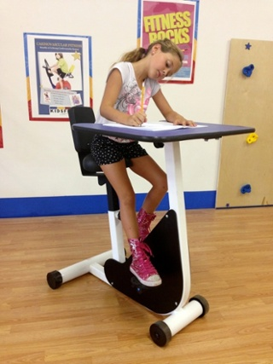
Contact

John Rutigliano, Tri-State Educational Director john@kidsfit.com 516-408-033

George Blessing, Educational Specialist george@kidsfit.com 516-462-2040

Action Based Learning is the leader in enhancing student performance and student wellness through movement. We are your one source for equipment, training, advantaged pricing and personalized room design! We are here to assist you in any way possible. If it is PD workshops, local data, funding resources or product information, please do not hesitate to reach out. Thank you for your time!

http://www.abllab.com

